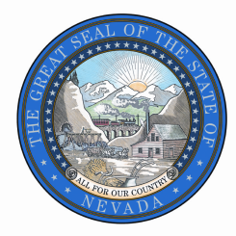
STATE OF NEVADA, GOVERNOR’S OFFICE
Public Records Request
Deliver, Mail, or Email to:
State Capitol Building, 101 N. Carson Street, Carson City, NV 899701
Fax: (775) 684-5670
Email: GovPublicRecords@gov.nv.gov

Date of Request
Requestor Contact Information
Name:
Organization:
Address:
City, State, Zip:
Phone:
E-mail:

Records Requested:
Check one: Paper copies Electronic copies Certified copies Inspection (in person)
Please be specific and include as much detail as possible regarding the records you are requesting.

To complete an estimate, the agency will need the following information:
I will pick up | Please FedEx  Fed Ex billing number: | Please send USPS | E-mail (if format allows)

Statement
I understand there is a charge for copies of public records. I understand I will receive a written estimate for production of the records indicated above if the estimated cost is expected to be over $25.00, which I will be required to pay in full prior to inspection or reproduction. Materials will be held for 30 days.
Requester Signature:
^{Signature}

Office Use Only

Request Status
Date
Request received
Receipt acknowledgement issues
Request filled
Estimated completion
Estimate provided
Request denied in whole
Other

Estimate: $
Date deposit received:
Actual (if different): $
Date final payment received:
Completed by:

Retain request form for three (3) calendar years from the end of the calendar year in which the response was completed according to RDS 2015013.

